**Abstract:**

**Problem statement:**

Summing vector field guidance may produce singularities, resulting in no guidance solution

**Motivation:**

**Background:**

Vector field benefits over conventional waypoint guidance

* Waypoints pre-planned
* Obstacles require waypoint re-planning
* VF can produce guidance for conventional waypoint paths and may be used for avoiding obstacles that were unknown during initial planning

**Contribution:**

Determining the location of singularities may be accomplished by solving for minimums in the summed guidance function.

Modifying vector field weighting parameters provides a method for eliminating or reducing the impact/severity of VF singularities.

**Introduction / Literature Review:**

* UAVs and waypoint path following
  + Pre-planned paths
  + May consider obstacles
  + Environment changes obstacles may have to be re-planned
* Obstacle avoidance may be achieved with on-board vector field guidance
* VF produce guidance for following straight line and circular paths (similar to Wpt)
  + VF guidance low error and robust (Sujit)
  + Primitives (Nelson)
  + Curved paths (Griffiths)
  + Goncalves n-d VF
    - Path of any shape
    - Accounts for TV nature of paths
    - Field weights easy access
    - Guaranteed to converge
  + Obstacles considered in standoff tracking (Wilhelm)
  + Various weighting functions for obstacles investigated in (Zhu)
* Summation of goal and obstacle fields can produce guidance singularities
  + Nelson (deadzones, sinks, singularities)
  + Motion planning and collision avoidance using VF (Panagou)
    - Singularities can be observed

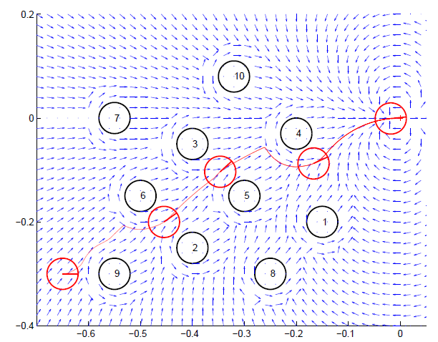

* Singularities represent points where no guidance exists
* Location of singularities are not trivial and difficult to solve due to non-linear guidance equations
  + Cylinder, hyperbolic tan decay
* Determining the location of singularities may be accomplished by solving for minimums in the summed guidance function.

**Method:**

* Present UAV kinematics (dubins vehicle)
* Present VF equation for straight path following
* Present VF equations for obstacle
  + Repulsion, small r
  + Decay function
  + No circulation (lacks information on how to go around obstacle)
* Singularity detection
  + Total field equation
    - Plot surface of field magnitude, point out global and local minimums
  + Solve for minimums
  + Array of initial conditions required to find points
    - Grid
    - On radius circle
    - Arc
  + Performance overview (Hz)
* Look-ahead singularity detection
  + Location of all guidance singularities for entire space is not necessary and computationally expensive
  + UAV flight envelope (Dubins vehicle based, axe)
    - Parameters?
  + Evaluating IC to find singularities inside flight envelope
* Modifying repulsive field to
  + Avoid singularities
  + Improve obstacle avoidance
  + Solve for some time horizon
    - VF variables (G,H,decay, etc)
  + Objective is to avoid obstacle singularities by adding modifying VF parameters
    - Second objective is to minimize distance flown?
    - Minimize deviation from VF path?

**Simulation:**

* Dubins UAV following a straight path
* Obstacle discovered
* Guidance must:
  + Determine location of singularities if inside flight envelope
  + Solve for VF parameters that remove singularities
  + Solve for VF parameters that result in guidance for minimizing error from path
* Various UAV speeds
* Various Obstacle positions on path
* Subsequent obstacles?
* Compare non-modified field with modified field based on:
  + Deviation from path
  + Total distance
  + Time spent in obstacle space
  + Yes/No obstacle avoidance success
  + Time spent finding solution